TROUBLESHOOTING TOOLS

Q1. Open the command prompt and use the ipconfig tool to find your computer's IPv4 address and default gateway, then take a screenshot of the output.
Ans.
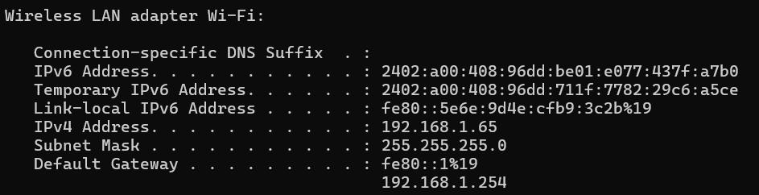
Q2. Use the ping command to check the connectivity between your computer and www.google.com, then note down the average response time shown.
Ans.
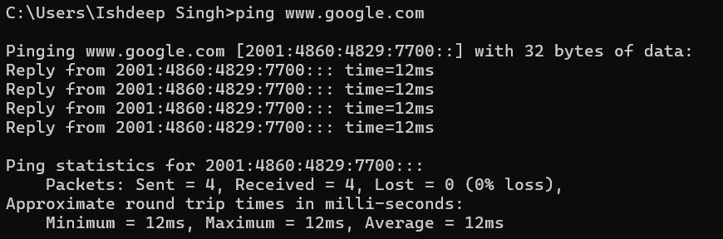
Q3. Run the tracert (or traceroute on Linux/Mac) command to www.flipkart.com and list the number of hops it takes to reach the destination.
Ans.
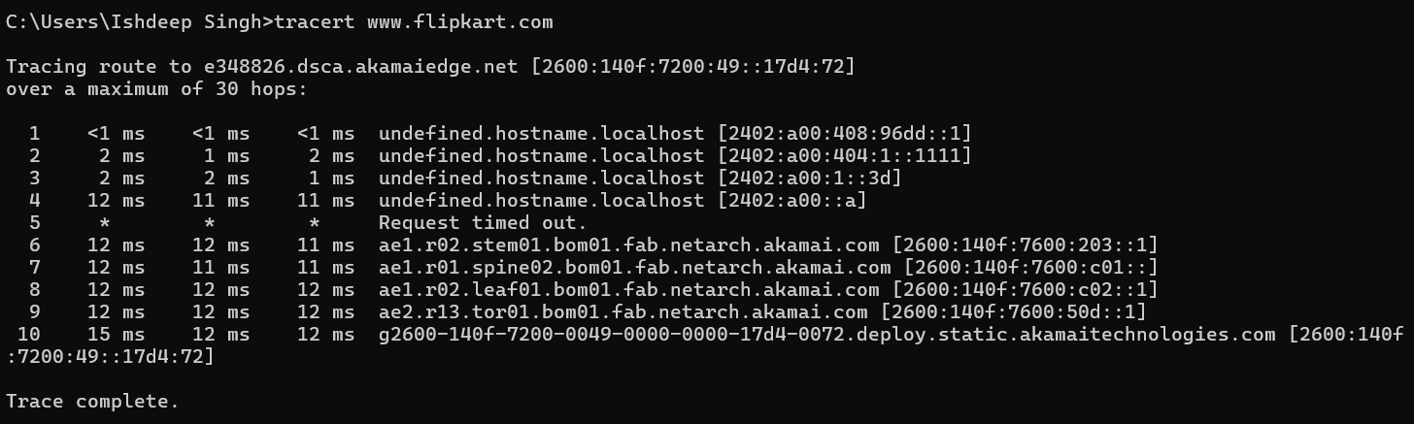

Q4. Use the nslookup tool to find the IP address of www.spotify.com and explain in one line what this tool helps you verify.
Ans.
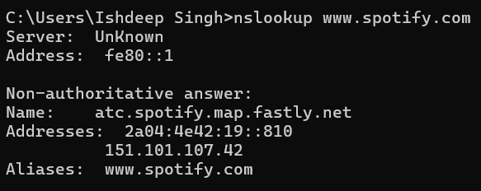
Q5. A friend says they cannot access Zomato’s website from their laptop. Suggest a sequence of three troubleshooting commands (choose from: ping, ipconfig, tracert, nslookup) you would run to diagnose the issue, and briefly state what each command would help you check. Hint: Think about checking both network connectivity and DNS resolution.
Ans. 3 Troubleshooting Commands
Step | Command | What it Checks
1 | Ipconfig | Checks whether the laptop has a valid IP address, subnet mask, and default gateway.
2 | Ping 8.8.8.8 | Tests basic Internet connectivity without relying on DNS.
3 | Nslookup Zomato.com | Checks whether DNS is resolving Zomato’s domain name to an IP address.

Diagnosis: If ipconfig looks correct and ping 8.8.8.8 works but nslookup zomato.com fails, the problem is likely related to DNS resolution.

